PRACTICAL 6

NAME: VRUTI MAKATI
ID: 25AIML032

1. Remote control: an interface Switchable with on()/off() and a default toggle(); Fan and
Light implement it. Loop over a Switchable[] toggling each. Then add a functional
interface that decides, given a device and an hour, whether it may switch on, and supply it
once as an anonymous class and once as a lambda.

2. Notification senders: a functional interface Notifier with send(String); make email and
SMS senders as lambdas, hold them in an array, and broadcast one message through all.
Add a marker interface Urgent and send twice for senders marked urgent.
3. (For Advanced Learners – home) Build a small discount engine where each rule is a
lambda the user picks at runtime and applies to a list of prices; organise it into packages
and ship it as a runnable JAR.
1st
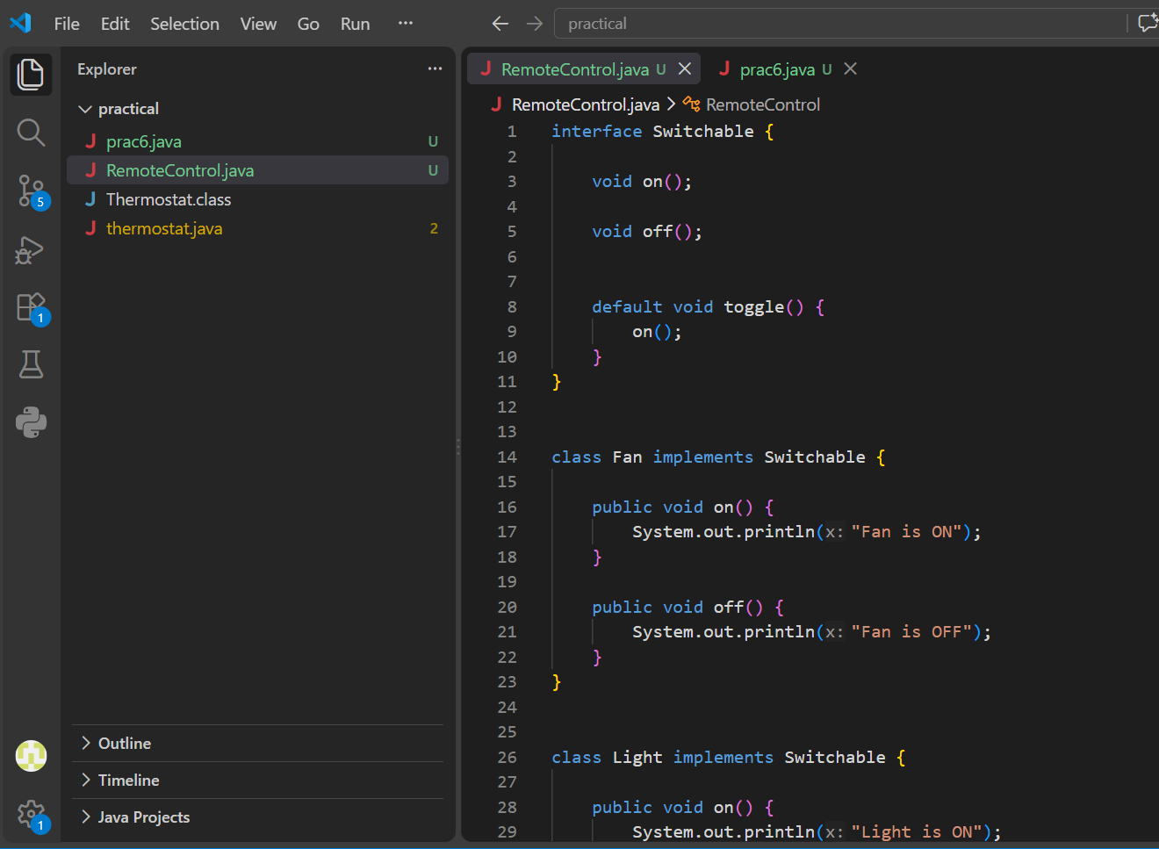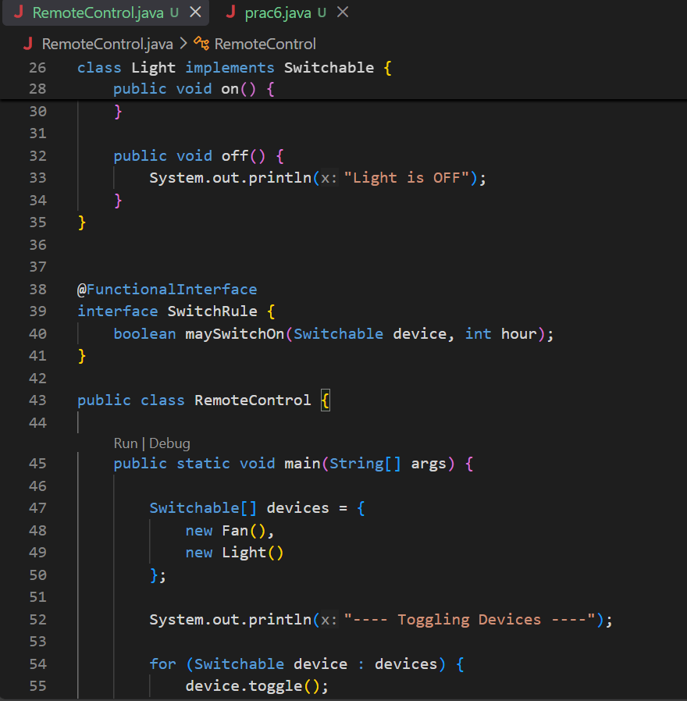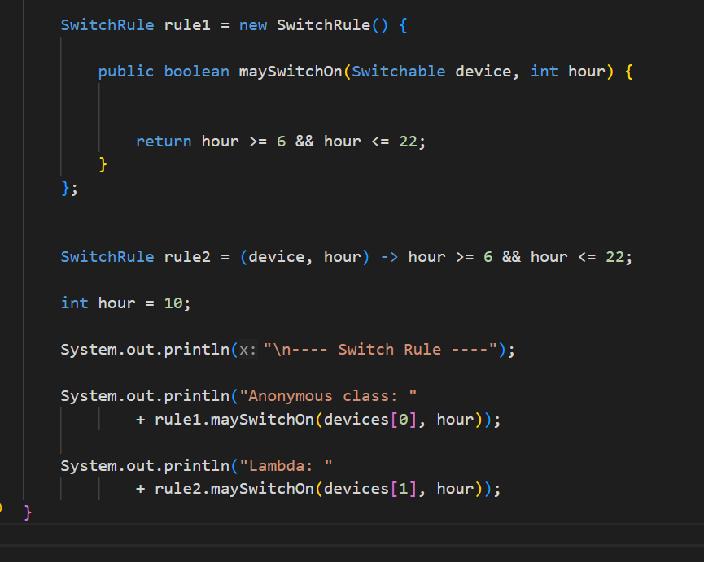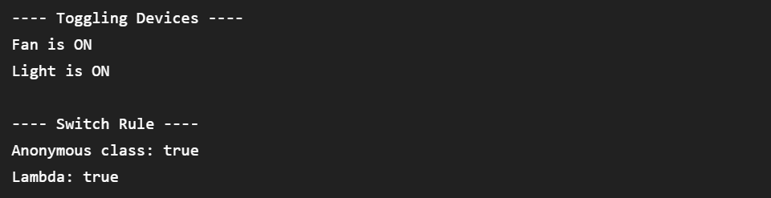

2nd
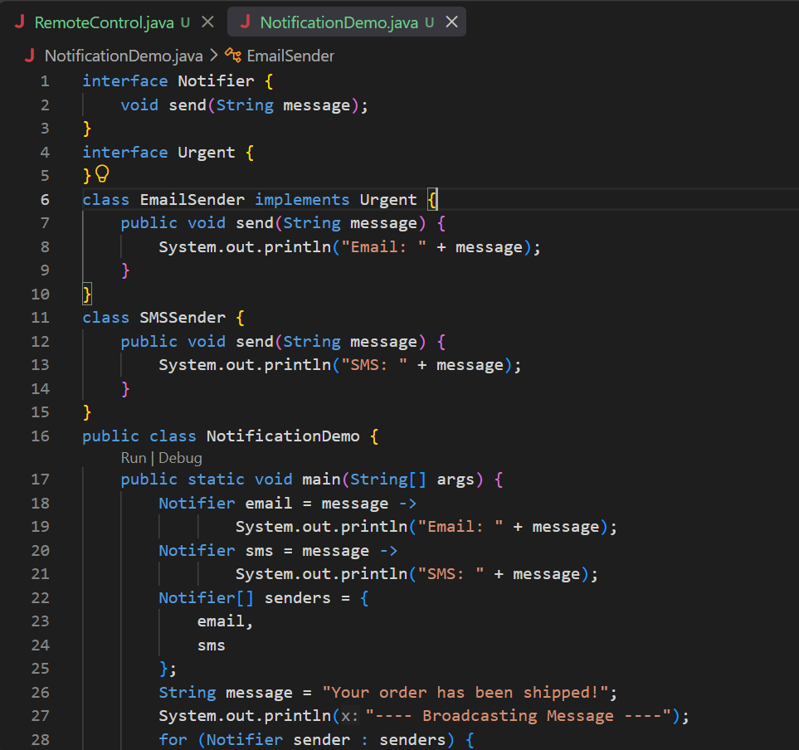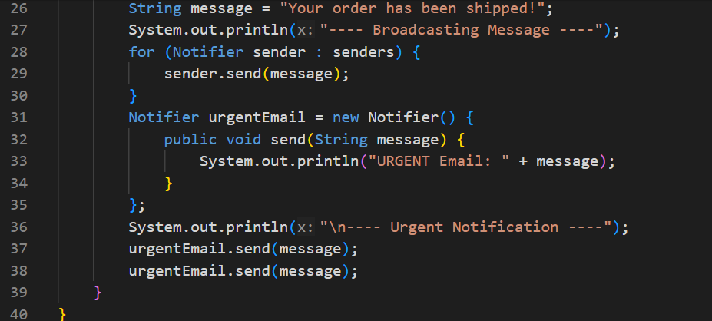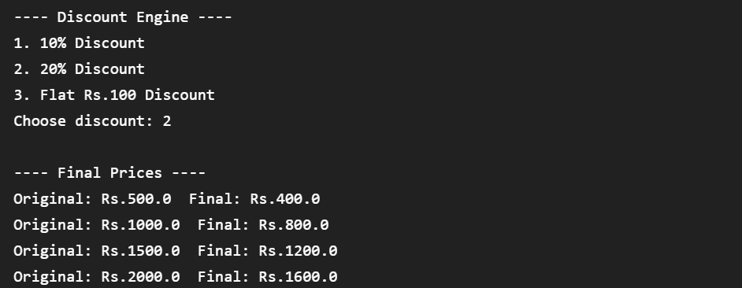
3rd
